INSTRUCTION MANUAL FOR CENTRIFUGE DSC-200D, DSC-300D
Lock
Lid
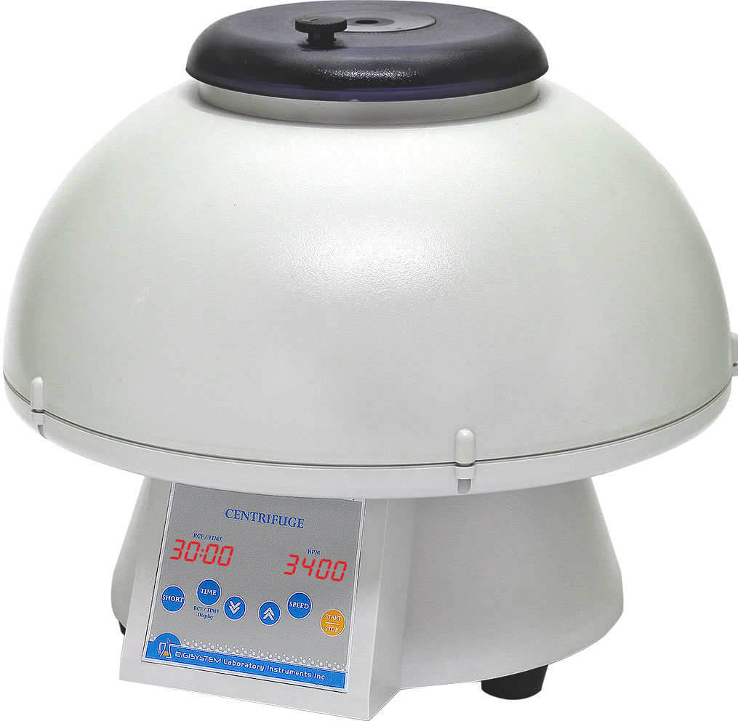
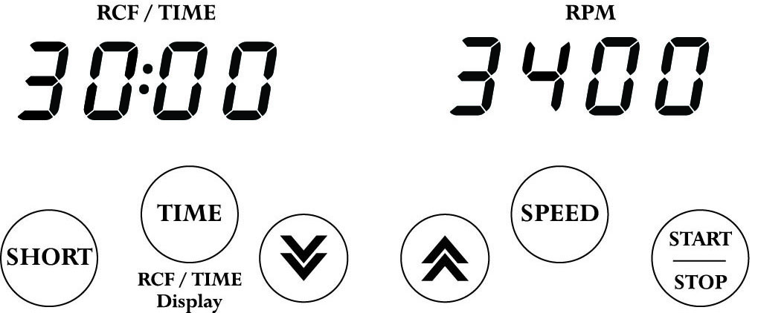
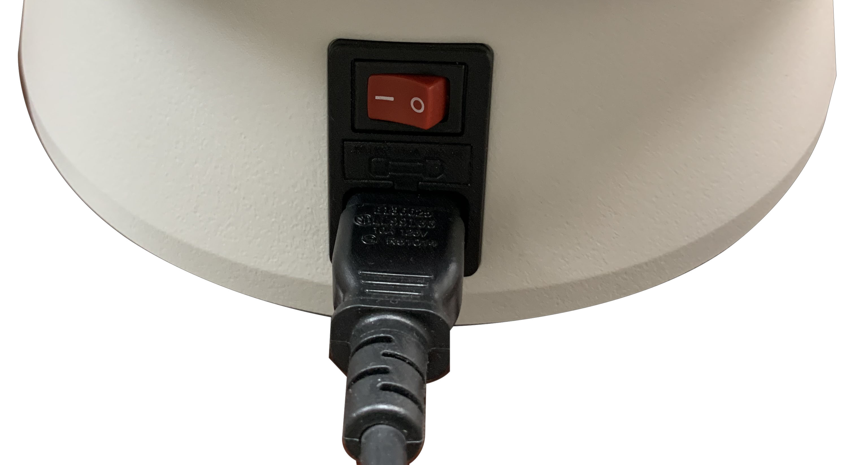

Power Switch
Control Panel

Warnings:
* Do not open the lid before the centrifuge stops completely.
* Do not remove the centrifuge during operation.
* Do not put objects on the top of the lid.
* Do not disassemble the centrifuge by yourself. In the event of a malfunction, the centrifuge should be repaired by a qualified technician. Before repairing, turn off the power.

Steps:
1. Place the centrifuge on a flat surface. Turn on the ‘Power Switch’ behind the machine.
2. Press and turn the ‘Lock’ ‘ left or right to open the ‘Lid’ of the centrifuge, then, place the tubes with specimen (each tube must be an equivalent in weight) into the tube holder. If only one specimen is tested, you should put other empty tubes with water in equal weight together for centrifugal.


3. Put the’ Lid’ down gently, and turn the ‘ Lock’ left or right to close the ‘Lid’.

4. Push the button and push the button or to set the speed value. Push the button or any other function button to enter the speed value. During the setting process, the right screen shows the speed value, and the left screen shows the R.C.F. value.

5. Push the button and push the button or to set the time value. Push the button or any other function button to enter the time value.
6. After setting speed and time value, push the button to start the centrifuge directly. During the operation, you may push the same button to stop the operation.

7. Push the button to start the centrifuge directly. Release the button and the centrifuge will stop immediately. The centrifuge will run to the current speed setting value.
8. During operation, the left screen shows the remaining time. When you push the button
, the left screen switch to show the R.C.F. value. Push the same button, the left screen switch to show the remaining time again.
9. After the machine stops completely, open the ‘Lid’ and take out the specimen.
10. During the operation, you may push the button to stop the machine.

Maintenance and care:
- Keep the centrifuge clean all the time. Cleaning can be done with a damp cloth. Avoid the use of solvents as they may damage the product housing, rotor.
- Check if the rotor is in the center. In case, the rotor is slanted. Stop using machine and contact the distributor for repair.

Circuit Diagram:
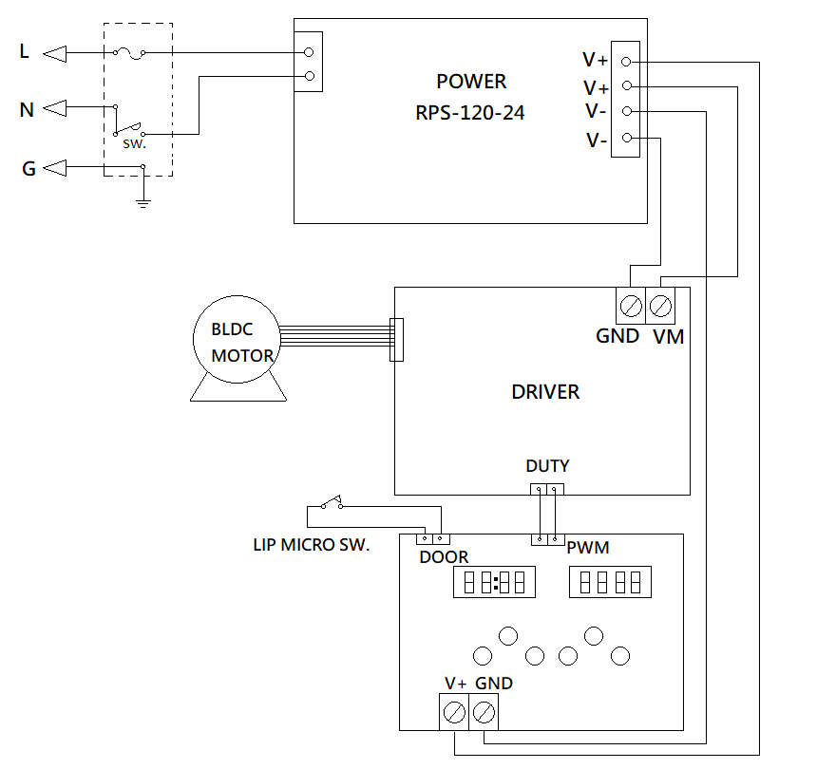

Service Manual

Troubleshooting Guide
Caution: Always disconnect the power cord before troubleshooting.
Trouble / error message | Cause | Remedy
Motor doesn’t work  (Error message : Er-P) | - Power supply is defective.  - Motor is defective.  - PC board is defective. | - Contract the distributor for repair.  - Contract the distributor for repair.  - Contract the distributor for repair.
Lid open error  (Error message : Er-d) | - During operation, the lid is open. | - Waiting for the motor stop completely. And close the lid.
Error message: run | - When the motor is rotating, push the START/STOP button. | - Waiting for motor stop completely, and then restart the centrifuge.
No display on the screen | - Power is off.  - Dead power output.  - Burnt fuse.  - PC board is defective.  - Power supply is defective. | - Turn on the power.  - Change to a different output.  - Replace a new fuse.  - Contract the distributor for repair.  - Contract the distributor for repair.
Burnt fuse | - Fuse is wasted.  - Power supply is defective. | - Replace a new fuse.  - Contract the distributor for repair.
Remark: To clear the error message, please turn off the power.

